**ECE 51018 HYBRID ELECTRIC VEHICLES**

# Project 2: Developing a Simulink-Based Semi-Detailed Simulation of a Permanent-Magnet AC Motor Drive

## April 2, 2021

Sai V. Mudumba

Instructor: Prof. Oleg Wasynczuk

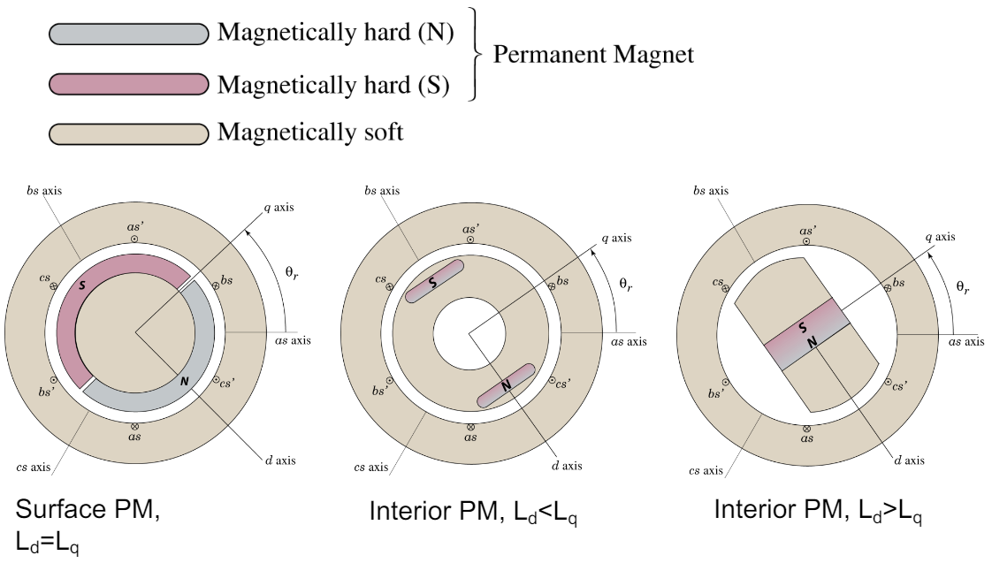

Figure taken from lecture notes from ECE 51018

**Problem Description**

The goal of this project is to develop a simulation model of the Permanent-Magnet AC Motor in Simulink. This motor utilizes a sine-triangular modulator with 3rd harmonic injection. The modulator uses a 20 kHz triangular carrier waveform. The rotor has 6-poles. We assume that the battery is an ideal voltage source. Later, this placeholder model for battery can be replaced with practical model for the battery. There is a 6-switch inverter circuit along with a DC filter. This filter is necessary to filter high frequency DC currents which can cause heating issues due to the oscillations.

Figure 1 shows the simplified circuit block diagram. The desired torque is provided as an input to the torque control module. Using steady state Park’s Equations shown in Eqns (1)-(4), the desired stator currents and voltages in the quadrature axis and direct axis are calculated, which are depicted in the rotor frame of reference.

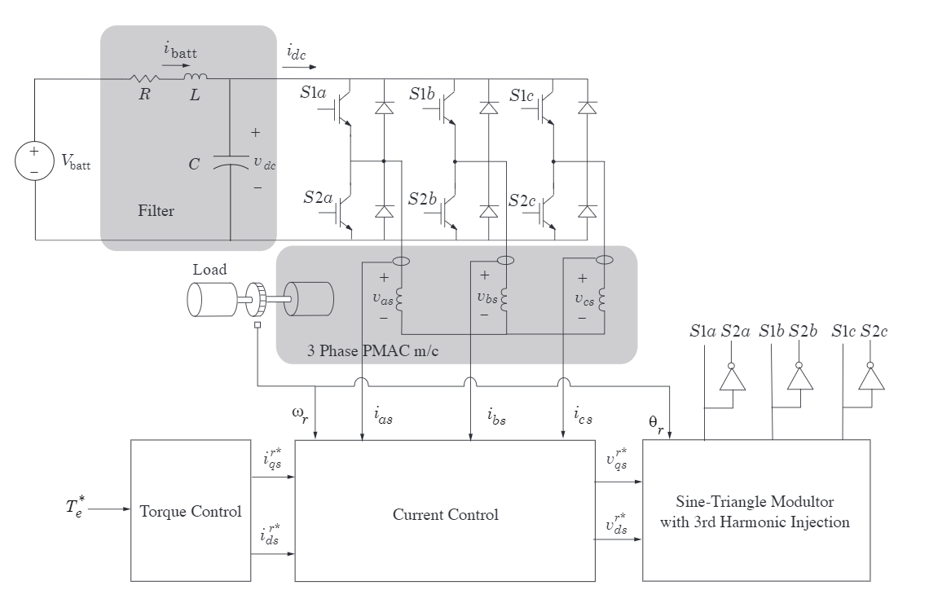

**Figure 1. Circuit Block Diagram [1]**

**Steady State Park’s Equations for Permanent Magnet AC Motors:**

|  |  |
| --- | --- |
| $$T_{e}=\frac{3}{2}\left(\frac{P}{2}\right)\left[λ_{m}^{'}I_{qs}^{r}+\left(L_{d}-L_{q}\right)I_{qs}^{r}I_{ds}^{r}\right]$$ | (1) |
| $$P_{e}=\frac{3}{2}\left(v_{qs}^{r}I_{qs}^{r}+v_{ds}^{r}I_{ds}^{r}\right)$$ | (2) |
| $$v_{qs}^{r}=r_{s}I_{qs}^{r}+ω_{r}L_{d}I_{ds}^{r}+ω_{r}λ_{m}^{'}$$ | (3) |
| $$v_{ds}^{r}=r_{s}I_{ds}^{r}-ω_{r}L_{q}I_{qs}^{r}$$ | (4) |
| $$v_{p}=\sqrt{v_{qs}^{r}+v_{ds}^{r}}$$ | (5) |
| $$ω_{rm}=\left(\frac{2}{P}\right)ω_{r}$$ | (6) |

**Table 1: Variable Definitions**

|  |  |
| --- | --- |
| Variable | Definition |
| $$T_{e}$$ | Electrical Torque (N-m) |
| $$P_{e}$$ | Electrical Power (kW) |
| $$P$$ | Number of Poles on the Rotor |
| $$λ_{m}^{'}$$ | Motor Flux Linkage (V-s/rad) |
| $$I_{qs}^{r}$$ | Stator Current along Quadrature Axis (A) |
| $$L_{d}$$ | Direct Axis Inductance (H) |
| $$L_{q}$$ | Quadrature Axis Inductance (H) |
| $$I_{ds}^{r}$$ | Stator Current along Direct Axis (A) |
| $$v_{qs}^{r}$$ | Stator Voltage along Quadrature Axis (V) |
| $$v_{ds}^{r}$$ | Stator Voltage along Direct Axis (V) |
| $$r_{s}$$ | Stator Resistance (Ω) |
| $$ω_{r}$$ | Electrical Rotor Speed (rad/s) |
| $$ω_{rm}$$ | Mechanical Rotor Speed (rad/s) |
| $$I_{max}$$ | Maximum Peak Current (A) |
| $$V_{batt}$$ | Battery Voltage (V) |
| C | Capacitance of the filter (F) |
| L | Inductance of the filter (H) |
| R | Resistance of the filter (Ω) |
| Kq | Proportional Gain for Quadrature axis current |
| Kd | Proportional Gain for Direct axis current |
| $$v_{as}$$ | Voltage along stator a-axis winding (V) |
| $$i_{as}$$ | Current along stator a-axis winding (A) |
| $$v_{dc}$$ | DC Voltage (V) |
| $$i_{dc}$$ | DC Current (A) |
| $$I_{batt}$$ | Battery Current (A) |

**Table 2: Given Parameters**

|  |  |
| --- | --- |
| Motor Parameters | |
| $$P$$ | 6 |
| $$λ_{m}^{'}$$ | 0.1062 V-s/rad |
| $$L_{d}$$ | 0.3 mH |
| $$L_{q}$$ | 0.3 mH |
| $$I_{max}$$ | 250 A |
| $$r_{s}$$ | 0.01 Ω |
| Source and Filter Parameters | |
| $$V_{batt}$$ | 350 V |
| C | 1 mF |
| L | 5 µH |
| R | 0.01 Ω |
| Current Regulator Parameters | |
| Kq | 0.5 Ω |
| Kd | 0.5 Ω |

**Analysis, Results, Discussion**

***Part 1: Write a MATLAB script that calculates and plots the first-quadrant maximum torque vs. speed envelope of the given drive system***

The envelope for electrical rotational speed ($w_{r}$) is 0 to 5000 rad/s. To convert to mechanical rotational speed ($w_{rm}$), the Equation (5) is used.

$$w_{rm}=\left(\frac{2}{P}\right)w_{r}$$

Various plots of the analysis are shown below (Figures 2 – 4). The code snippet used to plot various profiles is provided in Appendix A.

1. *Plot maximum torque (N-m) versus mechanical speed (rpm)*

The plot of maximum torque versus mechanical rotational speed is shown in Figure 2. The maximum torque is approximately 120 N-m, and it is constant from 0 to 4900 rpm. This constant torque is limited by maximum current, $I_{max}$, not by maximum voltage, $V_{max}$. The torque begins to decrease after 4900 rpm. This is due to limitations from both maximum current and maximum voltage.

1. *Plot maximum mechanical power (kW) versus mechanical speed (rpm)*

The plot of maximum mechanical power versus mechanical rotational speed is shown in Figure 3. The maximum mechanical power of about 75 kW is generated at approximately mechanical 8500 rpm. The maximum power generation decreases after 8500 rpm. There is a linear increase in power from mechanical speed of 0 rpm to 4900 rpm.

**Figure 2. Maximum Torque (N-m) versus Mechanical Rotational Speed Curve (RPM)**

**Figure 3. Maximum Mechanical Power (kW) versus Mechanical Rotational Speed (RPM)**

1. *Plot $I_{ds}^{r}$ needed for maximum torque versus mechanical speed (rpm)*

The plot of current $I_{ds}^{r}$ needed for maximum torque versus mechanical rotational speed is shown in Figure 4. The maximum torque happens when the $I_{qs}^{r}$ is maximized, as shown in Equation (1):

$$T_{e}=\frac{3}{2}\left(\frac{P}{2}\right)\left[λ_{m}^{'}I_{qs}^{r}+\left(L_{d}-L_{q}\right)I_{qs}^{r}I_{ds}^{r}\right]$$

$I_{qs}^{r}$ is maximized when $I_{ds}^{r}$ is set to 0A. Hence, in Figure 4, the $I_{ds}^{r}$ is 0A until 4900 rpm. When the peak voltage is reached, $I_{ds}^{r}$ needs to decrease in order to not violate the peak voltage constraint. This decreases $I_{qs}^{r}$, which decreases the maximum torque.

**Figure 4. $I_{ds}^{r}$ (A)** **versus Mechanical Rotational Speed (RPM)**

***Part 2a: Determine $I_{qs}^{r*}$ needed to develop 100 N-m at a mechanical speed of 3000 rpm.***

1. *Assume $I_{ds}^{r*}=0$. Using steady-state equations, calculate required $V_{qs}^{r*}$ and $V_{ds}^{r*}$.*

Steady-State Equations from Equations (1) – (6) are used.

$$T_{e}=\frac{3}{2}\left(\frac{P}{2}\right)\left[λ_{m}^{'}I_{qs}^{r}+\left(L_{d}-L_{q}\right)I_{qs}^{r}I_{ds}^{r}\right]$$

$$100=\frac{3}{2}\left(\frac{6}{2}\right)\left[0.1062*I_{qs}^{r}\right]$$

$$I_{qs}^{r*}=209.25A$$

Therefore, the quadrature stator current in the rotor frame of reference needed to develop 100 N-m of torque at a mechanical speed of 3000 rpm is approximately 209A. To calculate the required stator voltages in the rotor frame of reference, the following steady-state equations are used.

Assuming that , and , , we can find the voltages:

1. *Verify that given is sufficient.*

Let’s check the voltage constraint by calculating the peak voltage:

The peak voltage constraint is not violated. Hence, the provided is sufficient.

1. *Calculate the average power supplied to the motor and the average steady-state battery current*

To calculate the average power supplied to the motor, let’s use the following power equation:

$$P_{e}=\frac{3}{2}\left(v_{qs}^{r*}I_{qs}^{r*}+v_{ds}^{r*}I_{ds}^{r*}\right)$$

$$P_{e}=\frac{3}{2}\left(102.2*209.25\right)=32.1 kW$$

To calculate the average steady-state battery current, $I_{batt}^{^}$, we can use the following equation:

$${P_{batt}≅P}_{e}=V_{batt}I_{batt}^{^}$$

$$I_{batt}^{^}=\frac{32,100}{350}=91.7A$$

***Part 2b: Determine $I_{qs}^{r*}$ needed to develop -100 N-m at a mechanical speed of 3000 rpm.***

1. *Assume $I_{ds}^{r*}=0$. Using steady-state equations, calculate required $V_{qs}^{r*}$ and $V_{ds}^{r*}$.*

Steady-State Equations shown in Equations (1) – (6) are used.

$$T_{e}=\frac{3}{2}\left(\frac{P}{2}\right)\left[λ_{m}^{'}I_{qs}^{r}+\left(L_{d}-L_{q}\right)I_{qs}^{r}I_{ds}^{r}\right]$$

$$-100=\frac{3}{2}\left(\frac{6}{2}\right)\left[0.1062*I_{qs}^{r}\right]$$

$$I_{qs}^{r*}=-209.25A$$

Therefore, the quadrature stator current in the rotor frame of reference needed to develop 100 N-m of torque at a mechanical speed of 3000 rpm is approximately -209A. To calculate the required stator voltages in the rotor frame of reference, the following steady-state equations are used.

Assuming that , and , , we can find the voltages:

1. *Verify that given is sufficient.*

Let’s check the voltage constraint by calculating the peak voltage:

The peak voltage constraint is not violated. Hence, the provided is sufficient.

1. *Calculate the average power supplied to the motor and the average steady-state battery current*

To calculate the average power supplied to the motor, let’s use the following power equation:

$$P_{e}=\frac{3}{2}\left(v_{qs}^{r*}I_{qs}^{r*}+v_{ds}^{r*}I_{ds}^{r*}\right)$$

$$P_{e}=\frac{3}{2}\left(-98*209.25\right)=-30.76 kW$$

To calculate the average steady-state battery current, $I_{batt}^{^}$, we can use the following equation:

$${P_{batt}≅P}_{e}=V_{batt}I_{batt}^{^}$$

$$I_{batt}^{^}=\frac{-30,760}{350}=-87.9A$$

***Part 3: Simulink Modeling and Analysis***

In this part, we simulate a step change from 0A to 209.25A at 0.01 seconds, and at 0.02 seconds, we simulate a step change from 209.25A to -209.25. We examine how the steady-state response looks like for $v_{as}, i_{as},v_{dc},i_{dc},i_{batt}, T_{e}$. The detailed definitions of these variables are provided in Table 1. A Simulink model is developed that estimates the response times from time 0.00 to 0.03 seconds. The Simulink block diagrams are shown in Appendix B. Let’s discuss the resulting plots in the following section.

**Figure 5. Plot of $v_{as}$ vs response time**

The plot of $v_{as}$ vs response time is shown in Figure 5. The voltage is along the a-axis winding direction. The voltage oscillates between 100V and -100V until time of 0.01 seconds. When the $I_{qs}^{r*}=209.25A$ is desired, the voltage goes down to -180V and oscillates until the step change of $I_{qs}^{r*}=-209.25A$, when the voltage is -50V. Generalizing, this appears to be a phase shift in ac voltage.

**Figure 6. Plot of $i_{as}$ versus response time**

The plot of $i_{as}$ versus response time is shown in Figure 6. The current going through the a-phase winding is 0A up until 0.01 seconds. After step change to $I_{qs}^{r*}=209.25A$, this a-phase current oscillates between -206A to 206A. At the second step change to $I_{qs}^{r*}=-209.25A$ there is a phase shift in this current, which acts to provide a negative torque of -100 N-m.

The plot of $v_{dc}$ versus response time is shown in Figure 7. The voltage remains at 350V up to 0.01 seconds, and once the $I_{qs}^{r*}=209.25A$, the DC voltage oscillates around below 350V. Once the second step change is activated, $I_{qs}^{r*}=-209.25A$, the transient state oscillation has a slightly higher amplitude, but the steady state oscillates just above 350V.

The plot of $i_{dc}$ versus response time is shown in Figure 8. The DC current is 0A until the first step change to $I_{qs}^{r*}=209.25A$ occurs at 0.01 seconds. The DC current oscillates at approximately 91A. Once the second step change is made to $I_{qs}^{r*}=-209.25A$, the DC current is negative, and oscillating, at approximately -91A. This could represent current going into the battery during regenerative braking.

The plot of $i_{batt}$ versus response time is shown in Figure 9. The battery current is 0A until 0.01 seconds. Once the first step change is made to $I_{qs}^{r*}=209.25A$ at 0.01 seconds, the battery current reaches a steady state of 89A and, in the second step change to $I_{qs}^{r*}=-209.25A$ at 0.02 seconds, the battery current reaches a steady state of -86A.

The plot $T_{e}$ versus response time is shown in Figure 10. The torque is 0 N-m until 0.01 seconds, when the first step change to $I_{qs}^{r*}=209.25A$ increases the torque to 100 N-m. When the second step change occurs to $I_{qs}^{r*}=-209.25A$, torque decreases to -100 N-m. A negative torque means the vehicle could be in a braking condition, in which electrical energy is generated.

**Figure 7. Plot of $v_{dc}$ versus response time**

**Figure 8. Plot of $i_{dc}$ versus response time**

**Figure 9. Plot of $i_{batt}$ versus response time**

**Figure 10. Plot $T_{e}$ versus response time**

Table 3 shows comparison of values calculated in Part 2a, 2b with values calculated in Part 3. The steady state currents calculated in Part 3 are slightly smaller than those calculated in Parts 2a, 2b. The mechanical torques appear to be the same for both Parts 2a, 2b, 3.

**Table 3: Comparison of Values Calculated in Part 2a, 2b with Values Calculated in Part 3**

|  |  |  |  |  |
| --- | --- | --- | --- | --- |
|  | **Calculated values from Part 3** | | **Calculated values from Part 2** | |
| $$I_{qs}^{r*}=+209A$$ | $$I_{qs}^{r*}=-209A$$ | $$I_{qs}^{r*}=+209A$$ | $$I_{qs}^{r*}=-209A$$ |
| $$I_{batt}$$ | 89 A | -86 A | 91.7 A | -87.9 A |
| $$T_{e}$$ | 100 N-m | -100 N-m | 100 N-m | -100 N-m |
| $$v_{dc}$$ | 350 V | 350 V | 350 V | 350 V |
| $$I_{dc}$$ | 91 A | -91 A | 91.7 A | -87.9 A |

**REFERENCES**

[1] Wasynczuk, Oleg,. “Electric Machines and Drives,” *ECE 51018: Hybrid Electric Vehicles*, Accessed: April 2, 2021

**APPENDIX A**

% motor parameters

P = 6; % number of poles

lambda_m = 0.1062; %flux constant V-s/rad

r_s = 0.01; % stator resistance in ohms

L_d = 0.3e-3; %d-axis inductance in H

L_q = 0.3e-3; %q-axis inductance in H

% Filter parameters

L = 5e-6; % inductance in H

R = 0.01; % resistance in ohms

C = 1e-3; % capacitance in F

V_batt = 350; % battery voltage

I_max = 250; % maximum current in A

V_max = (V_batt)/sqrt(3); % maximum voltage in V

N_w = 5000;

w_r = linspace(0,N_w,N_w); %linspace(0, 5000, N_w); % electrical rotor speed in radians per second

% I_ds = linspace(0,I_max,1000); %linspace(0, I_max, N_i); % in Amps

I_ds = zeros(1,N_w);

for i = 1:N_w

I_qs(i) = sqrt(I_max^2 - I_ds(i)^2);

V_qs(i) = r_s*I_qs(i) + w_r(i)*L_d*I_ds(i) + w_r(i)*lambda_m;

V_ds(i) = r_s*I_ds(i) - w_r(i)*L_q*I_qs(i);

V_p(i) = sqrt(V_qs(i)^2 + V_ds(i)^2);

if V_p(i) < V_batt/sqrt(3)

Te(i) = (3/2)*(P/2)*(lambda_m*I_qs(i) + (L_d - L_q)*I_qs(i)*I_ds(i));

Pe(i) = (3/2)*(V_qs(i)*I_qs(i) + V_ds(i)*I_ds(i));

else

N_i = 7000;

I_ds_temp = linspace(-I_max,0,N_i);

Te_temp = zeros(1,N_i);

Pe_temp = zeros(1,N_i);

for j = 1:N_i

I_qs_temp(j) = sqrt(I_max^2 - I_ds_temp(j)^2);

V_qs_temp(j) = r_s*I_qs_temp(j) + w_r(i)*L_d*I_ds_temp(j) + w_r(i)*lambda_m;

V_ds_temp(j) = r_s*I_ds_temp(j) - w_r(i)*L_q*I_qs_temp(j);

V_p_temp(j) = sqrt(V_qs_temp(j)^2 + V_ds_temp(j)^2);

if V_p_temp(j) < V_batt/sqrt(3)

Te_temp(j) = (3/2)*(P/2)*(lambda_m*I_qs_temp(j) + (L_d - L_q)*I_qs_temp(j)*I_ds_temp(j));

Pe_temp(j) = (3/2)*(V_qs_temp(j)*I_qs_temp(j) + V_ds_temp(j)*I_ds_temp(j));

end

end

idx = Te_temp==max(Te_temp);

Te(i) = Te_temp(idx);

Pe(i) = Pe_temp(idx);

I_qs(i) = I_qs_temp(idx);

I_ds(i) = I_ds_temp(idx);

V_qs(i) = V_qs_temp(idx);

V_ds(i) = V_ds_temp(idx);

V_p(i) = V_p_temp(idx);

end

end

w_rm = (2/P)*w_r;

w_rm_rpm = w_rm*(60)/(2*pi);

figure(1)

plot(w_rm_rpm, Te, 'LineWidth',1)

ylim([0,130])

title('Maximum Torque versus Mechanical Rotational Speed Curve')

xlabel('Mechanical Rotational Speed (RPM)')

ylabel('Torque (N-m)')

figure(2)

plot(w_rm_rpm, Te.*w_rm/1000)

title('Maximum Mechanical Power versus Mechanical Rotational Speed Curve')

xlabel('Mechanical Rotational Speed (RPM)')

ylabel('Power (kW)')

figure(3)

plot(w_rm_rpm, I_ds)

title('I_{ds}^r current needed for Maximum Torque')

xlabel('Mechanical Rotational Speed (RPM)')

ylabel('I_{ds}^r (A)')

ylim([-250 250])

**APPENDIX B**

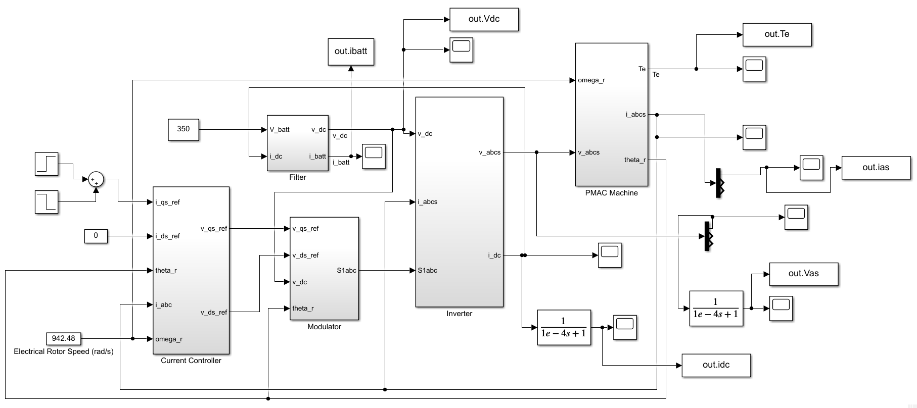**Figure 11. Simulink Block Diagram**